Servo Motor Notes

# DSServo

http://www.dsservo.com/en/

## DS3218

20kg metal gear Digital servo DS3218  
Size:40*20*40.5(servo)  
Weight:60g  
Wire length:320mm  
Speed: 0.14sec/60 degree at(6v)  
              0.16sec/60 degree at(7.2v)  
Torque: 18kg.cm.at(6v)  
               20kg.cm.at(7.2v)  
Voltage: 4.8v-7.2v  
Dead Zoon setting:4 Microseconds  
Features:  
- Durable Metal Gear  
- Dual Ball Bearing  
- Programmable Digital Amplifier with Mosft Drive  
- Bottom Side Axial Mount Hole  
- Original factory product  
- Less Noise  
-Contains: Metal Holder  
-Orientation Angle:maximum 180 degree  
It's also widely used for RC Cars.

Neutral Position

1500us

Range

Pulse width range is 500us to 2500us

Can use travel range 180 or 270 deg

Rotation is counter clockwize

500us 0 deg

2500us 180 deg or 270 deg

# Tutorial

## **Introduction**

[Servo motors](https://www.sparkfun.com/categories/245) are an easy way to add motion to your electronics projects. Originally used in remote-controlled cars and airplanes, they now crop up in all sorts of other applications. They’re useful because you can precisely control the positioning of these motors. Instruct them where to point, and they’ll do it for you.

[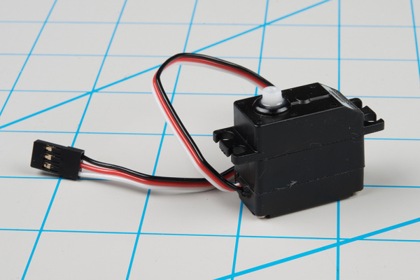](https://cdn.sparkfun.com/assets/learn_tutorials/5/2/6/servo_6.jpg)

A typical hobby servo

An ordinary DC motor has two hookup wires and simply turns continuously when power is applied. If you want it to spin in the opposite direction, you’ll need to reverse the power. And if you want to know how far it has turned, you’ll need to devise a way to measure that.

[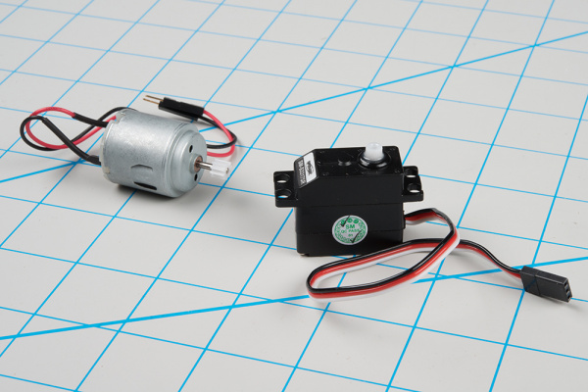](https://cdn.sparkfun.com/assets/learn_tutorials/5/2/6/servo-and-dc.jpg)

DC motor (left) and hobby servo

In contrast, you instruct a servomotor where to turn using carefully-timed pulses. The servo has three wires: power, ground, plus a third wire to carry the command pulses.

### **Suggested Reading**

* An [Introduction to Motors](https://learn.sparkfun.com/tutorials/motors-and-selecting-the-right-one).
* Some background on [Pulse Width Modulation](https://learn.sparkfun.com/tutorials/pulse-width-modulation).

## **Servo Motor Background**

In the most generic sense, a “[servomechanism](https://en.wiktionary.org/wiki/servomechanism)” (servo for short) is a device that uses feedback to achieve the desired result. Feedback control is used in many different disciplines, including speed, position, and temperature.

In the context we are discussing here, we are talking about hobby or radio-control servo motors. These are small motors primarily used for steering radio-controlled vehicles. Because the position is easily controllable, they are also useful for robotics and animatronics. However, they shouldn’t be confused with other types of servo motors, such as the large ones used in industrial machinery.

[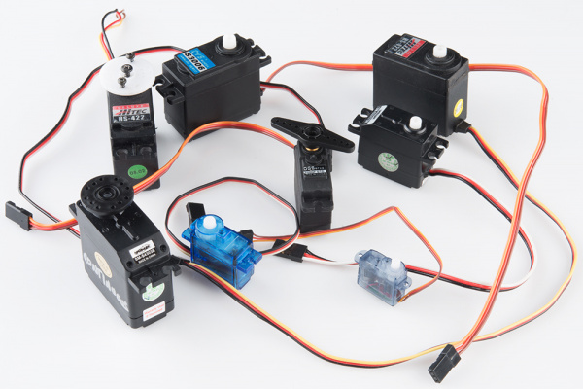](https://cdn.sparkfun.com/assets/learn_tutorials/5/2/6/servo-samples.jpg)

An Assortment of Hobby Servos

RC servos are reasonably standardized - they are all a similar shape, with mounting flanges at each end, available in graduated sizes, from “[ultra-nano](https://www.sparkfun.com/products/11882)” to “[giant](https://www.sparkfun.com/products/11881)”. Servos often come with multiple attachments, such as wheels or levers, known as “horns”, than can be attached to the shaft, to fit the device they are operating.

[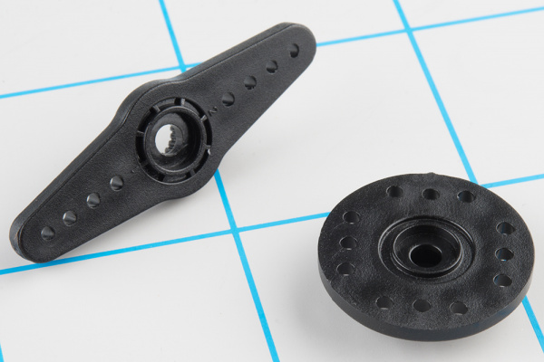](https://cdn.sparkfun.com/assets/learn_tutorials/5/2/6/servo-horns.jpg)

Example Servo Horns

### **Electrical Connection**

Most hobby servos use a standard type of 3-pin plug, with the same control signaling, which makes RC servos reasonably interchangeable.

The connector is a female, 3-pin, 0.1" pitch header. One thing that can be confusing is that the wiring color code isn’t always consistent – there are several color codes at play. The good news is that the pins are usually in the same order, just that the colors are different.

[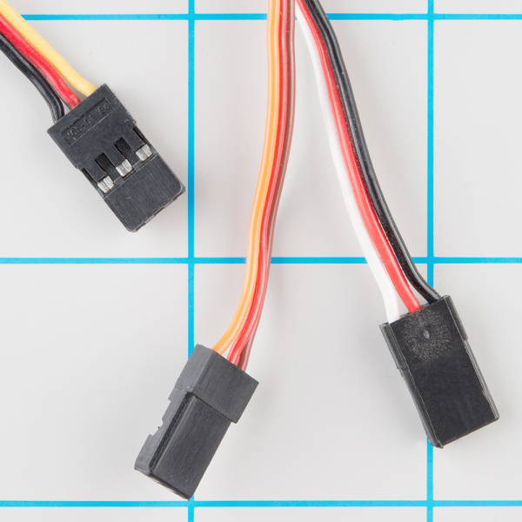](https://cdn.sparkfun.com/assets/learn_tutorials/5/2/6/servo-color-code.jpg)

Servo Cables

The table below summarizes common color schemes. A useful mnemonic is that the most drab color (black or brown) is usually ground, and red is usually the power supply.

|  |  |  |  |  |
| --- | --- | --- | --- | --- |
| **Pin Number** | **Signal Name** | **Color Scheme 1 (Futaba)** | **Color Scheme 2 (JR)** | **Color Scheme 3 (Hitec)** |
| 1 | Ground | Black | Brown | Black |
| 2 | Power Supply | Red | Red | Red or Brown |
| 3 | Control Signal | White | Orange | Yellow or White |

Servo connection Color Coding

**Heads up!** If you’re in doubt about your color scheme, check the documentation – don’t plug it in backwards!

### **Control signal**

The third pin of the servo connector carries the control signal, used to tell the motor where to go. This control signal is a specific type of pulse train. The pulses occur at a 20 mSec (50 Hz) interval, and vary between 1 and 2 mSec in width. The [Pulse Width Modulation](https://learn.sparkfun.com/tutorials/pulse-width-modulation) hardware available on a microcontroller is a great way to generate servo control signals.

Common servos rotate over a range of 90° as the pulses vary between 1 and 2 mSec – they should be at the center of their mechanical range when the pulse is 1.5 mSec.

[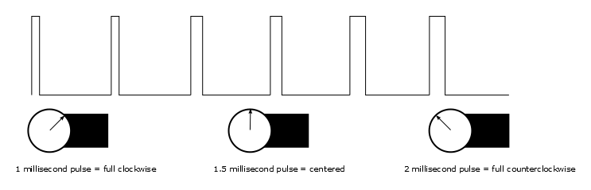](https://cdn.sparkfun.com/assets/learn_tutorials/5/2/6/pulse-illus.png)

pulse to position

### **Powering Servos**

In RC vehicles, the nominal battery voltage is 4.8V. It will be somewhat higher after a charge, and it will droop as the batteries discharge. As the voltage drops, the available torque also drops – if you’ve driven RC vehicles, you’re no doubt familiar with the loss of control that occurs as the batteries get weaker. It starts to feel sluggish just before it dies.

If you’re not using batteries, the 5VDC available from a garden variety power supply is a good option. If you’re using an Arduino or other microcontroller (such as the SparkFun [Servo Trigger](https://www.sparkfun.com/products/13118)) to control your motor, the **absolute maximum**supply voltage that should be applied is **5.5 VDC**.

Regardless of how you’re powering them, it’s worth noting that the current consumed by the motor increases as the mechanical loading increases. A small servo with nothing attached to the shaft might draw 10 mA, while a large one turning a heavy lever might draw an Ampere or more! If your power supply isn’t up to the task, a straining or stalled servo can cause the supply to sag, which may have other unpredictable repercussions, such as causing microcontrollers to reset.

Additionally, if you’ve got multiple servos, or in applications where the motors are moving non-trivial loads, it’s best to use heavy gauge wires and give each servo a direct connection to the power supply, rather than daisy-chaining power from one to the next. This configuration is commonly known as “star power.” If one servo causes the power rail to droop, it’s less likely to effect the others when each has a direct connection.

[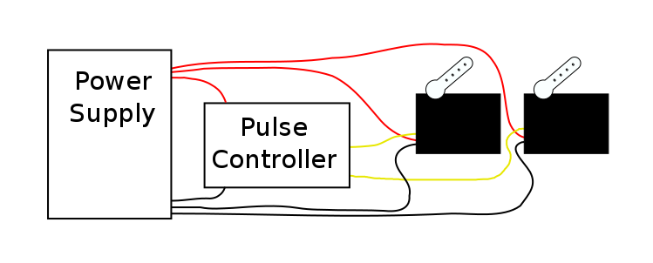](https://cdn.sparkfun.com/assets/learn_tutorials/5/2/6/servo-star2.png)

Star power.

When in doubt, grab a multimeter, measure the current consumed, and check whether VCC sags when the servos are turning.

### **Show Me The Guts**

Internally, the mechanism of a servo motor uses a potentiometer attached to the rotating shaft to sense the position. It measures the width of the incoming pulse and applies current to the motor to turn the shaft, until the potentiometer indicates that the position corresponds to the incoming pulse width. This is a form of feedback control. The motor has received the desired position from the pulse width, and the actual shaft position is fed back to the circuit via the potentiometer. It compares the desired value to the actual value and drives the motor in the direction that causes actual to match desired.

Here are the insides of a servo that’s been dissected. You can see the gears, DC motor, position potentiometer, and a small PCB. The PCB has a chip on one side, possibly a small microcontroller or specialized servo IC.

[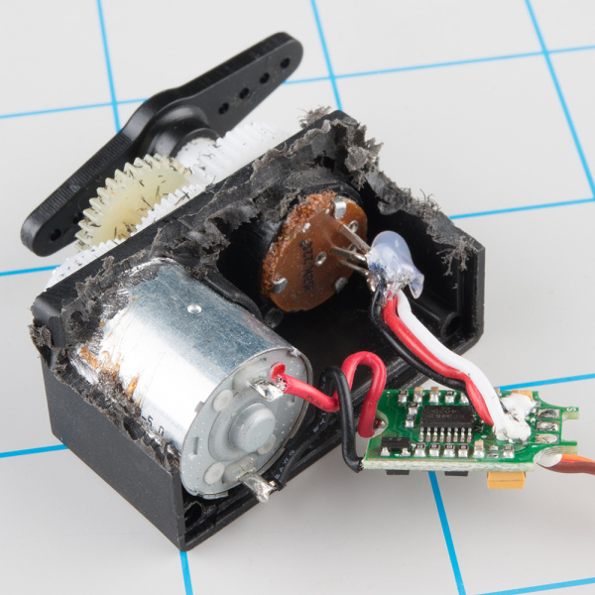](https://cdn.sparkfun.com/assets/learn_tutorials/5/2/6/servo-guts_1.jpg)

Inside an RC servo

The other side of the PCB has some discrete transistors, probably in an H-bridge configuration, which allow the controller to steer current through the motor in either direction, for both clockwise and counterclockwise rotation.

[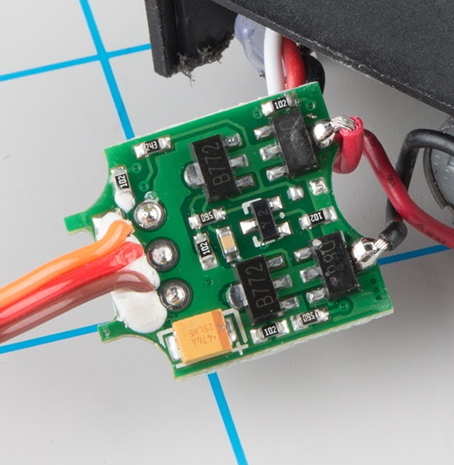](https://cdn.sparkfun.com/assets/learn_tutorials/5/2/6/servo-guts2.jpg)

Back of the PCB

## **A Handful of Distinctions**

When you’re shopping for servos for your project, there are several parameters that you’ll want to keep in mind.

### **Range Constraints**

The 1-to-2 millisecond pulse range is more of a convention than a hard-and-fast standard. Some servo motors respond to even shorter or longer pulses with an extended range of motion.

Be warned that there is a risk – this expanded range of motion isn’t universal. Some servos are mechanically limited to 90° rotation. Attempting to drive them beyond their limits can cause damage, such as stripped gears. The servo that we see dismantled here suffered exactly that fate.

[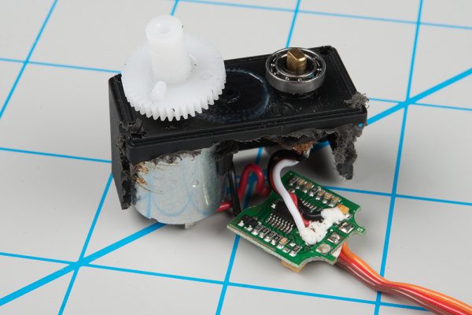](https://cdn.sparkfun.com/assets/learn_tutorials/5/2/6/range-constraint.jpg)

The nub on the gear is used to constrain the range of rotation.

### **Position vs. Continuous Rotation**

Moving even further from the 90° range, there are also **full rotation**, **continuous rotation**, or simply **360°** servos. As the name states, the shaft turns continuously, making them useful as drive motors. Visually, they look just like regular servos.

[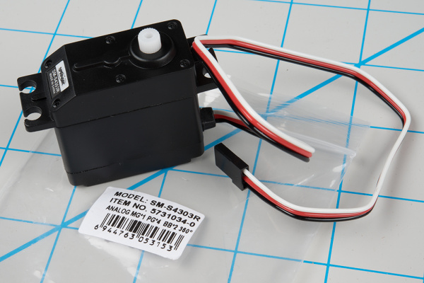](https://cdn.sparkfun.com/assets/learn_tutorials/5/2/6/cr-servo.jpg)

Look carefully, and you’ll notice the “360°” mark on the packaging.

Rather than controlling position, the continuous rotation servo translates the 20 mSec pulse-train signal into the rotational speed and direction of the shaft. Otherwise, they’re very similar to regular RC servos – they use the same power supply, control signals, 3-pin connector, and are available in the same sizes as RC servos.

The overall speed is relatively low – around 60 RPM is a common maximum rate – if you need higher rotation speed, servos aren’t the best fit – [DC gearmotors](https://www.sparkfun.com/categories/247) or brushless DC motors are more likely candidates, but they aren’t directly compatible with servo control signals.

[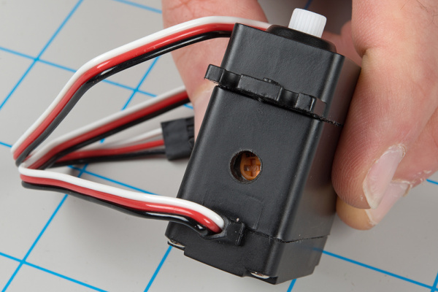](https://cdn.sparkfun.com/assets/learn_tutorials/5/2/6/cr-servo-trimmer.jpg)

Nulling Trimpot

On closer inspection, continuous rotation servos have one small difference from regular servos: they usually have a “nulling” trimpot, used to adjust their response to the control signal. It’s typically set so that a 1.5 mSec pulse stops the motor. Shorter pulses will cause it to turn counterclockwise, and longer pulses cause it to turn clockwise.

### **Analog vs. Digital**

The pulse-controlled servos we’re discussing here are analog. There are also [digitally-controlled](http://hitecrcd.com/faqs/servos/digital-servos) servos that use a high-speed pulse train, and have a [serial communication](http://hitecrcd.com/products/servos/digital-servo-programmers-2/hfp-25-digital-servo-programmer-tester-2/product) interface that allows more detailed configuration, typically with parameters that are tailored to RC vehicles.

### **Plastic vs. Metal Gears**

One last thing to look at when considering a servo is the type of gears it contains.

Inexpensive servos (such as the one dismantled here) usually contain molded plastic gears, while more expensive servos have metal gears. Plastic gears are more likely to strip if the motor is jammed or overloaded. The old adage rings true: you get what you pay for.

[](https://cdn.sparkfun.com/assets/learn_tutorials/5/2/6/gear-2.jpg)

Note the missing tooth at about 3:00 o'clock on the inner gear!

## **Deploying Servos**

### **Traditional RC Application**

As we stated in the introduction, the usual application of hobby servo motors is for steering radio-controlled vehicles.

[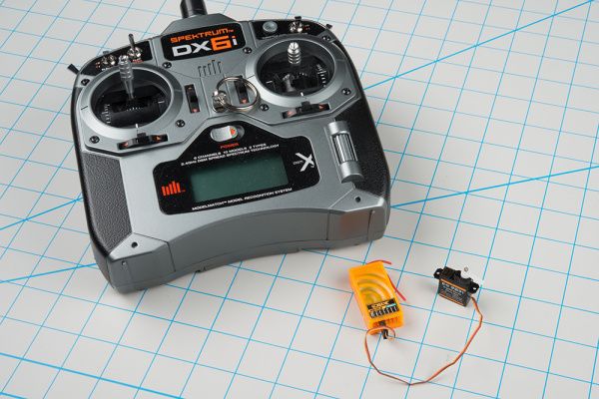](https://cdn.sparkfun.com/assets/learn_tutorials/5/2/6/rc-rig.jpg)

RC transmitter (top left), with receiver and steering servo.

RC vehicles are controlled with a transmitter unit – the box with the joysticks and antenna. The transmitter sends control information to receiver modules (the orange box shown above), which connect to the servo motors. When the sticks on the transmitter are moved, the receiver generates corresponding pulses, instructing the motors to move.

Configuring older RC craft required a fair amount of patience, because adjusting the servos meant careful mechanical tweaking of the servo horns, mechanical linkages, and trim controls on the transmitter. Modern transmitters and receivers are microcontroller-based, tweaked through the LCD on the transmitter, or even a computer interface.